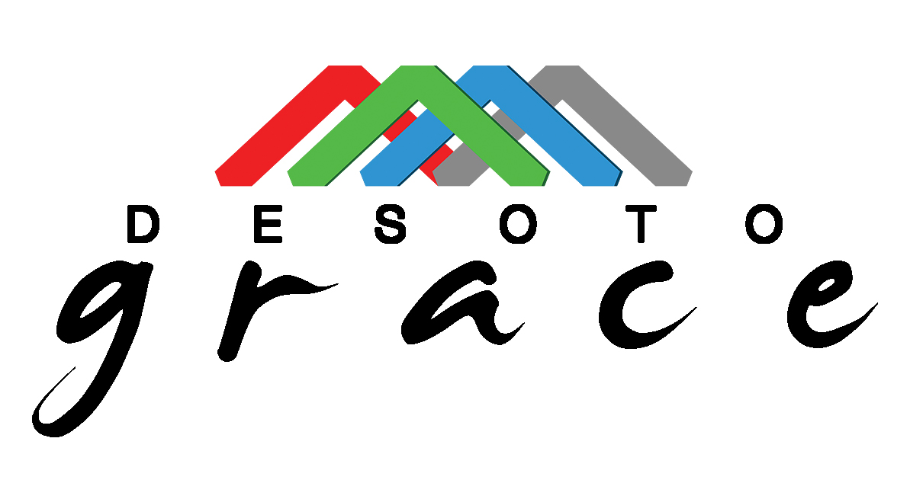

Your student has been recommended for the DeSoto Grace Education Program!

DeSoto Grace is a nonprofit organization established to provide free educational assistance to qualifying students in DeSoto County schools. This program is specifically for students who will be in the third, fourth or fifth grade in the 2021-2022 school year. We provide education assistance for language arts and math as well as homework assistance.

You must fill out an application and go through an interview process to see if your student will qualify. Since we are a “needs” based program we evaluate the educational, relational, physical and financial needs of the student and their family when making the determination. We will begin interviews soon for our 2021-2022 program so please complete the online application as soon as possible. Space is limited and will fill up quickly.

You will see a link below for our online application. Please complete this if you would like to be considered for this free program. After receiving the completed application, someone will be in contact to provide more information as well as next steps. We look forward to the possibility of working with your student.

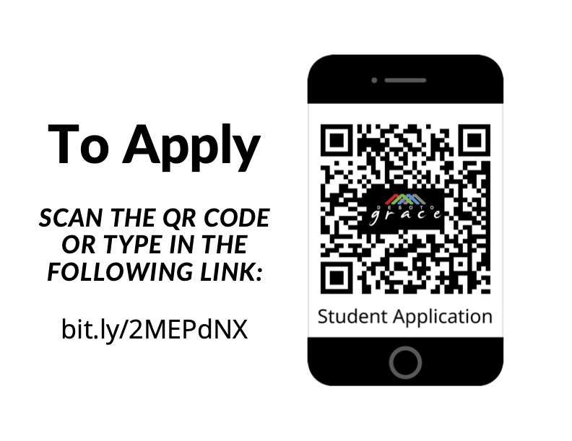

Thank you!

Kim Belknap
DeSoto Grace Education Program
Desotograce.kbelknap@gmail.com
901-517-3821

